**Smart Touch Administrator vs Account Administrator**

**Purpose of this document**

The purpose of this document is to differentiate and categorize the administrative levels that shall be defined in the Smart Touch Module. It is to ensure a streamlined behavior throughout the application and to standardize the administrative responsibilities.

The basic difference between these two roles is that the Smart Touch Administrator is an administrator to all the accounts available in Smart Touch whereas an Account Administrator is an administrator for a specific account (at an account level).

The system shall identify the Smart Touch Administrator based on the…..

**Smart Touch Administrator**

1. A Smart Touch Administrator shall have the access to all the modules and privileges to perform any activity in the application.
2. An ‘Account’ can be created in Smart Touch by the ST Administrator.

[ST System Administrator will have the access to all the modules available throughout Smart Touch]

1. Once an account is created by the ST Administrator, a notification is sent to the primary email address that has been provided to the admin.

The account shall be created as per the subscription to the modules.

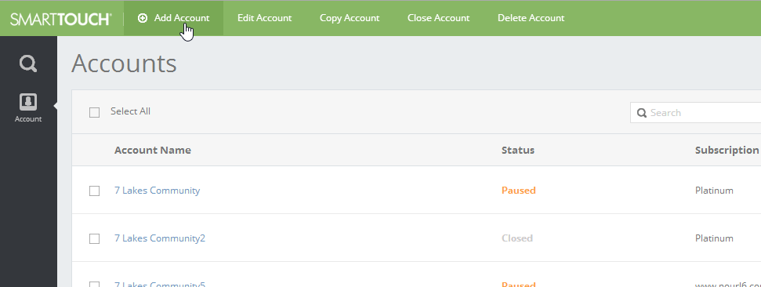 ***The above snapshot depicts the Account screen from where an ST Administrator can create a new account.***

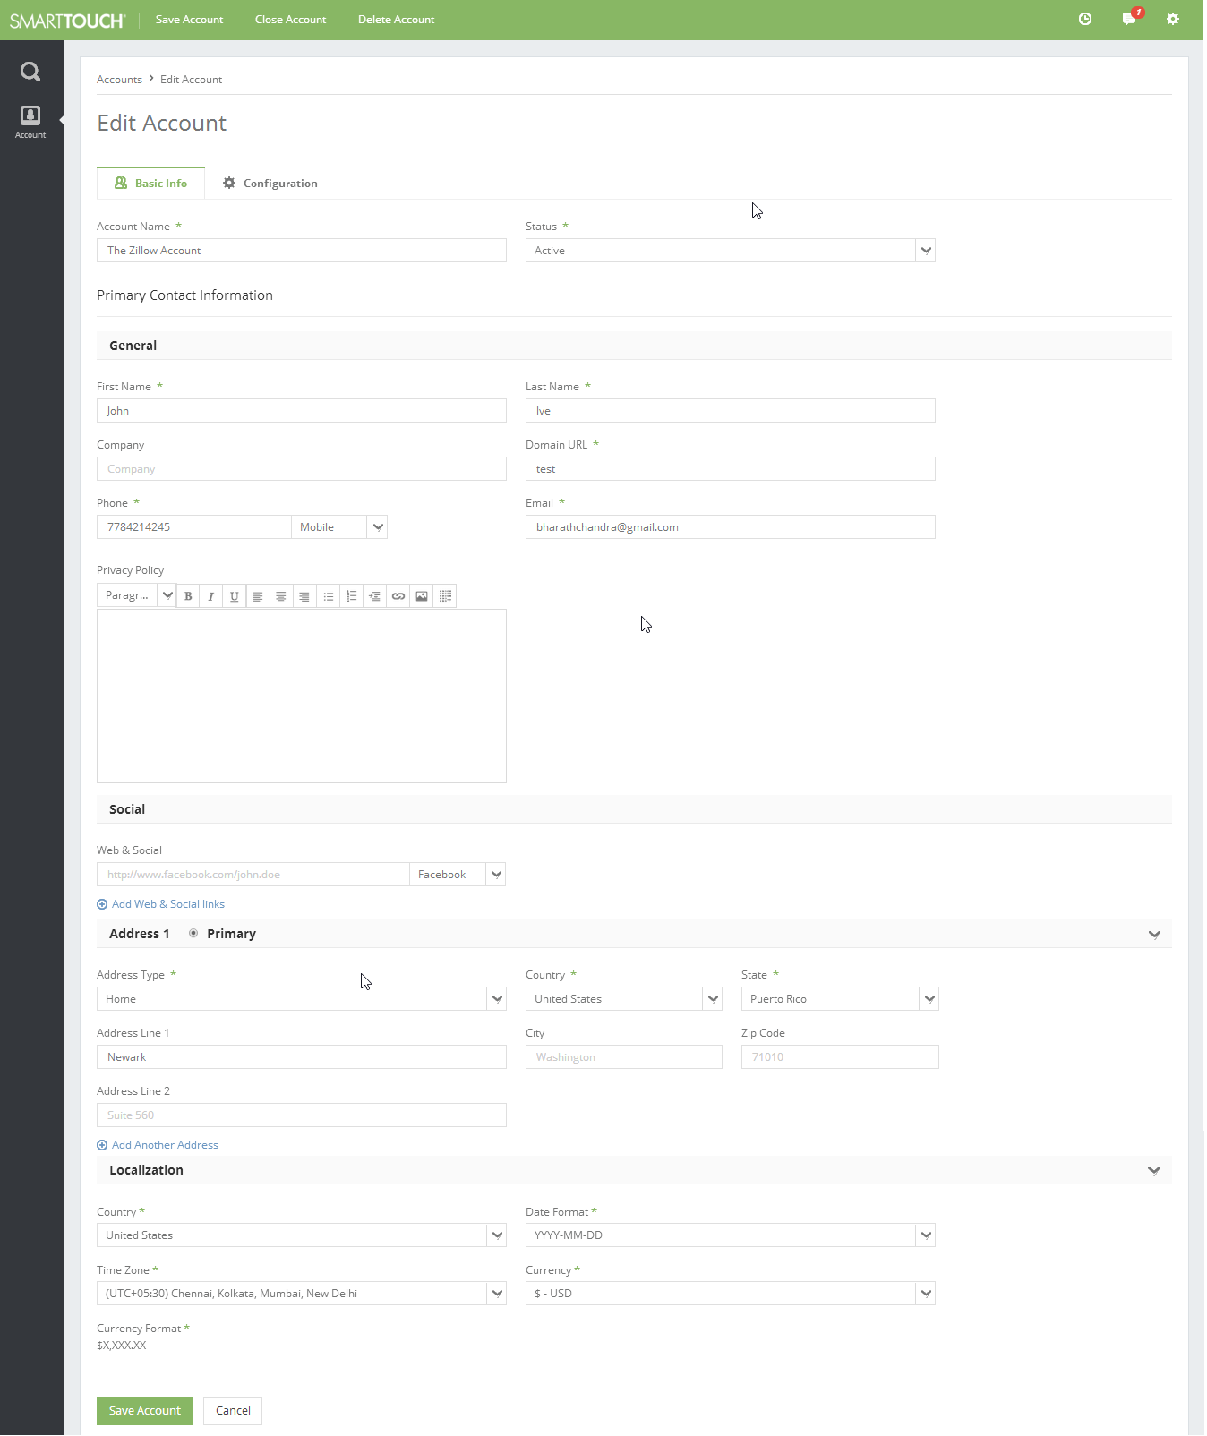***The snapshot above depicts the Basic Info tab in the Create/Edit Account screen for a ST Administrator.***

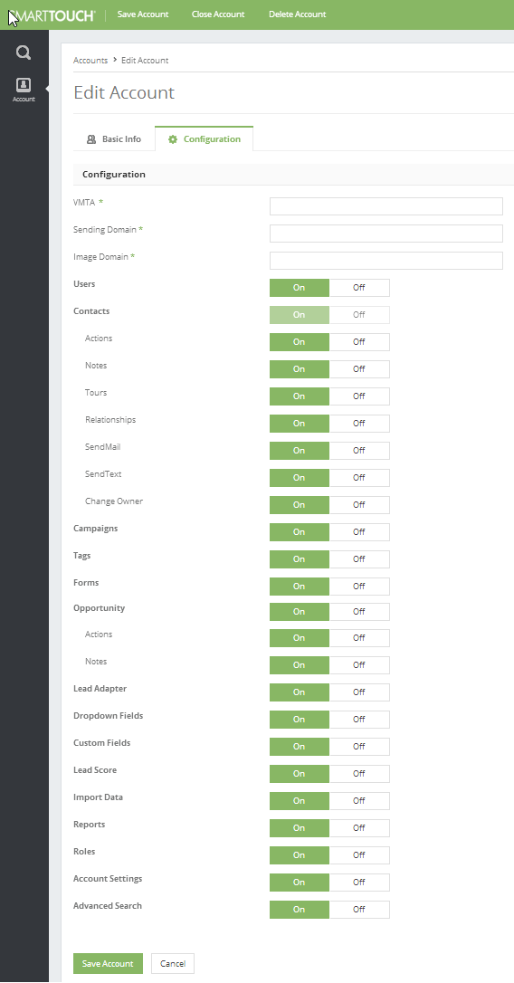 ***The snapshot above depicts the Configuration tab in the Create/Edit Account screen for a ST Administrator.***

1. Once an Account is defined, a user will be created for this account by the ST Administrator. This newly created user will be selected as the Account Administrator (for the created account). This role cannot be assigned to multiple users for an account. The ‘Account Administrator’ value role shall not be available in the ‘Role’ dropdown list.

The system shall generate a validation saying **“A user already exist with this role. Multiple users cannot be associated to this role”.**

[Note: The ‘Account Administrator’ value role shall not be available in the ‘Role’ dropdown list.]

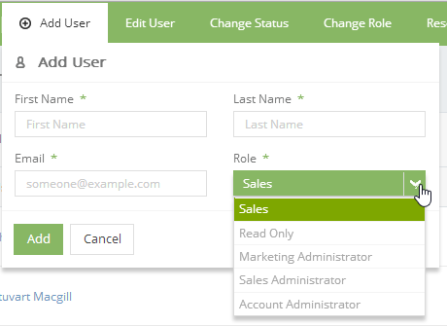

1. Only the ST System Administrator, while creating a user shall see the ‘Account Settings’ responsibility in Roles module. This responsibility can only be provided to a single user for a given account. The user having this responsibility shall behave as the Account Administrator for that specific account.



**Responsibilities of an Account Administrator**

1. The Account Administrator will have all the permissions for all the subscribed modules available for a particular account by default. These options (the checkboxes) are read-only and cannot be edited.
2. The Account Administrator can define multiple custom roles for their account as per the subscription access available for that account. The following activities shall be available for the Account Administrator.

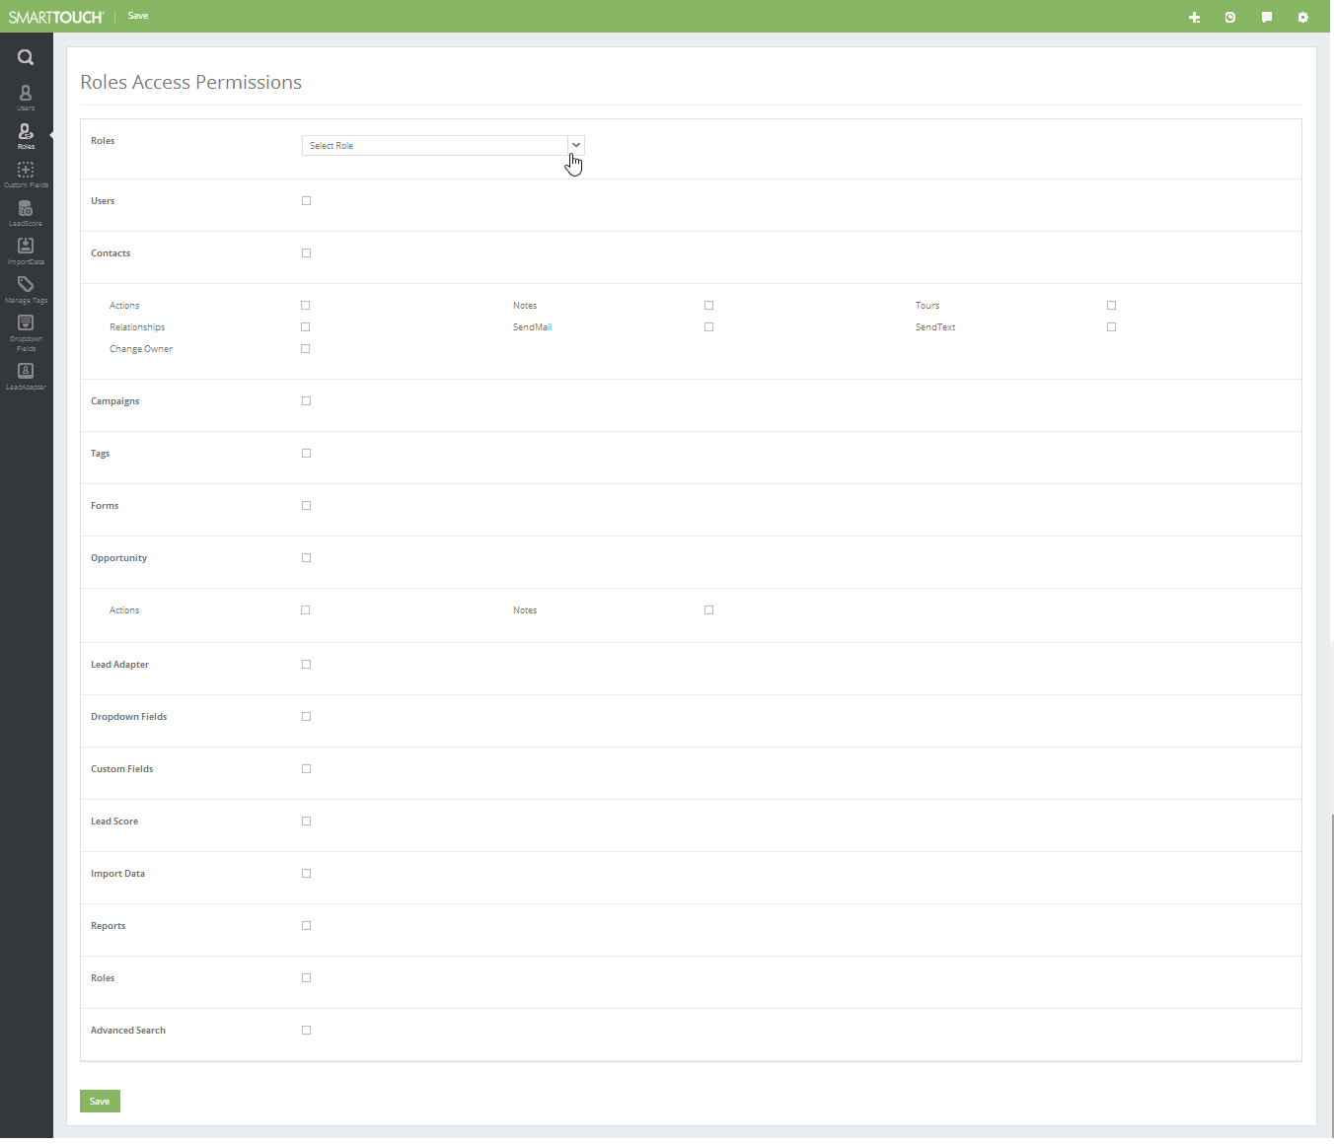 ***The snapshot above depicts the permissions available in the Roles module for an Account Administrator.***

1. The user who is the Account Administrator should not be listed in the Users module. The details for this user can be accessed from the My Profile option that is available in the list on the top-right-corner of the screen.

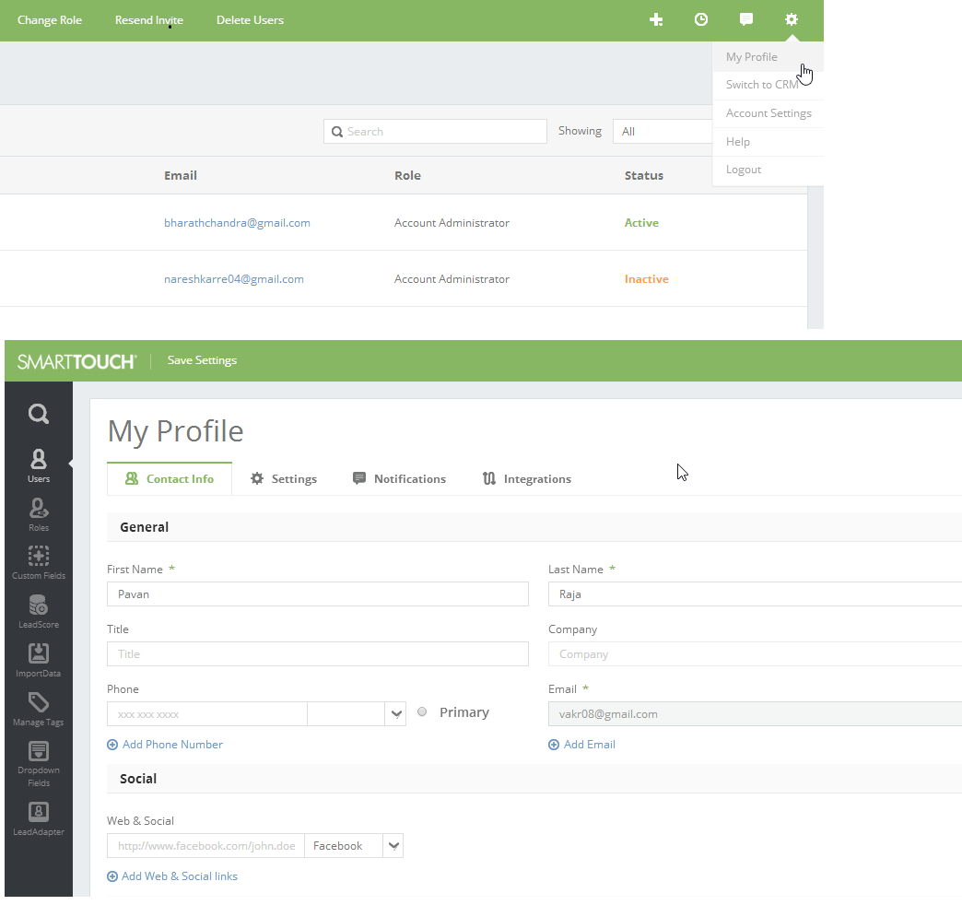

**General Assumptions**

1. The system shall have the following roles with only one user associated to each of these roles.

* Smart Touch Administrator
* Account Administrator

It is to be noted that these two roles cannot be duplicated.

1. It is to be noted that there could exist only one administrator at an account level. This is to ensure that the creation of users and roles can be controlled and ensure a consistent approach.

In case of a requirement, where there could be a need of two Account Administrators for a single account, a ticket has to be raised that shall be addressed.

**Email Notifications**

Notifications shall be triggered for the following scenarios:

* When the Smart Touch Administrator creates an account with the primary email address, an email notification will be sent to the id post completion of the account creation.
* When the Smart Touch Administrator creates the Account Administrator, an email notification shall be sent, requesting the Account Administrator to login and edit their details.

**Technical Points to Remember**

**Use Cases**

* The ST Administrator shall have the access to an account as an Account Admin for all the accounts within Smart Touch.
* The ST Administrator shall not have the access to create more than one Account Admin for a given account.
* The ST Administrator shall have the access to create user(s) for any account within Smart Touch.
* The Account Administrator shall not have the access to create another Account Administrator for their account.
* There can exist two different email id’s – 1. The id used to activate the account and 2. The id associated to the Account Administrator.